ELECTRONICS RETAIL SALES DASHBOARD
Using Microsoft Power BI
Project Report
Submitted By:
Name: Swarnalakshmi J
Roll Number: E25FA045
Programme: B.Com FinTech and AI
Tool Used: Microsoft Power BI Desktop
File: Electronics Retail Sales.pbix (Dataset 6)

1. Introduction
This report documents the Power BI project built on the Electronics Retail Sales dataset (Dataset 6). The dataset has nine related tables covering sales transactions, orders, products, customers, stores, salespeople, cities, states and dates. The Power BI file contains three report pages: DAX Validation, Retail Sales Dashboard and Store Type Tooltip. Together they allow a user to study revenue, profit, orders and quantity sold by product, store, city, state, customer segment and time period without working through the raw tables.
The work covered the complete Power BI workflow: importing the CSV files, cleaning and typing the data in Power Query, building a star-schema data model, writing DAX measures, validating them with slicers, designing a dashboard, and adding drill-down, tooltips, conditional formatting and sparklines.

Objectives
- To import and clean nine CSV files and assign correct data types in Power Query.
- To build a star-schema model with eight Many-to-One relationships.
- To create and format eight basic DAX measures.
- To validate that every measure responds correctly to filters from each dimension table.
- To summarise revenue, profit, orders and quantity through KPI cards.
- To compare performance by product category, store, city and store type.
- To track revenue over time with a year-to-month trend.
- To make the dashboard interactive using slicers, drill-down, tooltip, data bars, sparklines and edited visual interactions.

2. Dataset Overview
Nine CSV files were imported and the Power BI file was saved as Electronics Retail Sales.pbix. Every table was inspected in Data view and Model view, and each field was classified as an identifier, category, numerical or date field. After import, table names were renamed with the first letter capitalised.
Table | Type | Description
Fact Sales | Fact | Sales transactions: IDs, quantity, unit price, discount, tax, subtotal, total amount, cost, profit, profit margin and return details.
Dim Product | Dimension | Product code, name, category, subcategory, brand, unit cost, unit price, warranty, stock and launch details.
Dim Customer | Dimension | Customer name, gender, date of birth, registration date, customer segment and active status.
Dim Store | Dimension | Store name, store type, closing date, online ordering flag and city link.
Dim Salesperson | Dimension | Salesperson records with active status and audit dates.
Dim Date | Dimension | Calendar attributes: day, month, month name, quarter, year, fiscal year, fiscal quarter and full date.
Dim Order | Dimension | Order date, gift, priority and returned flags, cancellation and return dates.
Dim City | Dimension | City name linked to a state.
Dim State | Dimension | State name.

3. Data Preparation in Power Query
Each table was opened in the Power Query Editor and its columns were assigned the correct data types. The main rules applied are summarised below.
Table | Columns | Data type applied
Fact Sales | sales_id, store_id, salesperson_id, date_id, customer_id, product_id, order_id, quantity | Whole Number
Fact Sales | unit_price, discount_amount, discount_rate, tax_amount, subtotal, total_amount, cost_amount, profit_amount, profit_margin, tax_rate | Decimal Number
Fact Sales | return_date; created_at, updated_at | Date (locale changed); Date/Time then Date using locale
Fact Sales | is_returned | True/False (custom column [is_returned] = "t")
Dim City / Dim State | city_id, state_id; city_name; created date | Whole Number; Text; Date/Time then Date using locale (English, India)
Dim Product | product_id, warranty_months, stock_quantity; unit_cost, unit_price, weight; launch_date, discontinued_date | Whole Number; Decimal Number; Date
Dim Product | is_active, is_discontinued | True/False (custom columns using "t")
Dim Customer | customer_id; names and gender; date_of_birth, registration_date; is_active | Whole Number; Text; Date; True/False
Dim Date | date_id, day, month, quarter, year, fiscal_year, fiscal_quarter; full_date | Whole Number; Date
Dim Salesperson | created and updated dates; is_active | Date; True/False
Dim Store | closing_date; is_active, has_online_ordering | Date; True/False
Dim Order | order_date, cancellation_date, return_date; is_gift, is_priority, is_returned | Date; True/False

Converting "t" to True/False
Boolean columns were stored as the text "t". To convert them, a custom column was added for each field using a formula such as [is_active] = "t". The new column was set to True/False, the original column was removed, and the new column was renamed to the original name. Blank salesperson_id values in Fact Sales were deliberately preserved and not replaced with artificial IDs.

4. Data Model and Relationships
All automatic relationships were deleted and eight relationships were created manually, and all are Active. The model follows a star schema with Fact Sales at the centre.
No. | From (Many) | To (One)
1 | Fact Sales[product_id] | Dim Product[product_id]
2 | Fact Sales[customer_id] | Dim Customer[customer_id]
3 | Fact Sales[store_id] | Dim Store[store_id]
4 | Fact Sales[salesperson_id] | Dim Salesperson[salesperson_id]
5 | Fact Sales[date_id] | Dim Date[date_id]
6 | Fact Sales[order_id] | Dim Order[order_id]
7 | Dim City[state_id] | Dim State[state_id]
8 | Dim Store[city_id] | Dim City[city_id]

The Manage relationships window confirms that all eight relationships exist and are Active. Seven of them (Dim City → Dim State, Dim Store → Dim City, and Fact Sales → Dim Customer, Dim Date, Dim Product, Dim Salesperson and Dim Store) are shown as Many-to-One (*:1) with a single filter direction. The Fact Sales (Order_id) → Dim Order (Order_id) relationship is shown as One-to-One (1:1) with a both-direction filter. This is because every order in this dataset has exactly one sales record (15,000 orders and 15,000 transactions), so Power BI detected a one-to-one match. If the assignment requires *:1 with a single direction for this relationship as well, it can be changed in Edit relationship.
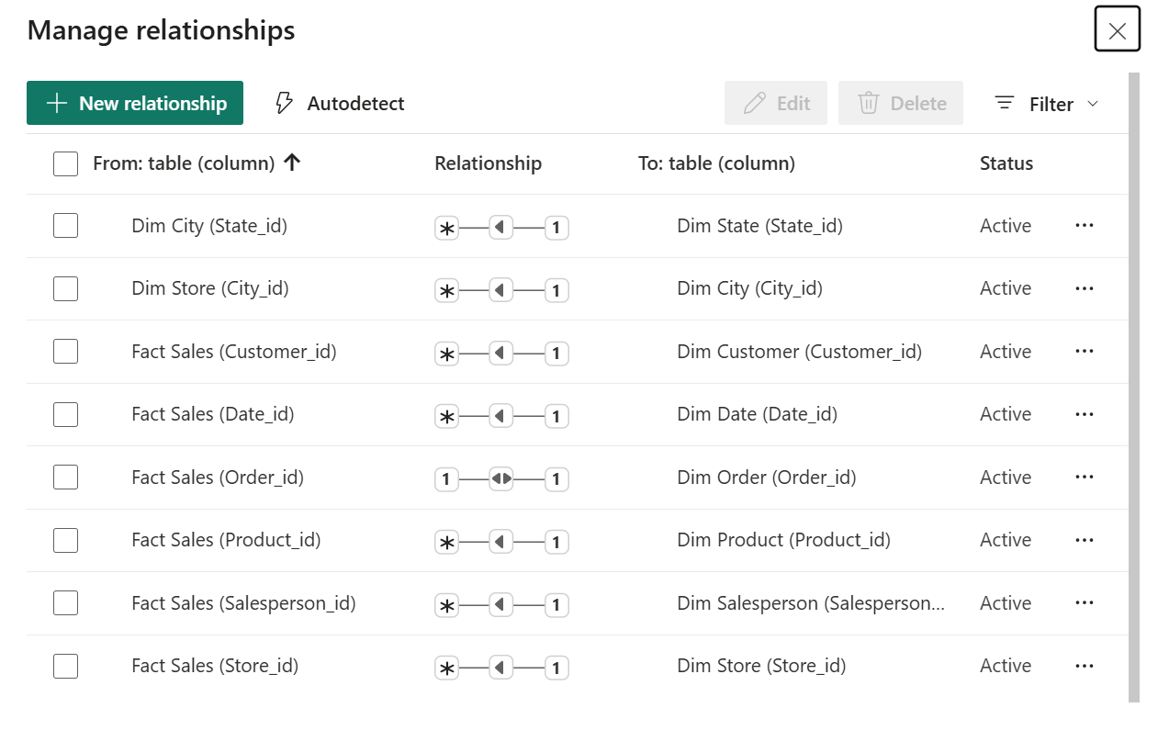
Figure: Manage relationships window showing the eight relationships

5. Measures Created
Eight DAX measures were created in the Fact Sales table and formatted as shown. Revenue, cost, profit and price measures use the rupee (₹) currency format; quantity, transactions and orders are whole numbers.
Measure | DAX formula | Format
Total Quantity | SUM('Fact Sales'[quantity]) | Whole number
Total Revenue | SUM('Fact Sales'[total_amount]) | Currency (₹)
Total Cost | SUM('Fact Sales'[cost_amount]) | Currency (₹)
Total Profit | SUM('Fact Sales'[profit_amount]) | Currency (₹)
Average Unit Price | AVERAGE('Fact Sales'[unit_price]) | Currency (₹)
Total Transactions | COUNT('Fact Sales'[sales_id]) | Whole number
Total Orders | DISTINCTCOUNT('Fact Sales'[order_id]) | Whole number
Average Order Value | DIVIDE([Total Revenue], [Total Orders]) | Currency (₹)

Total Transactions and Total Orders are expected to differ, because one order can contain several sales records.

6. Validation of DAX Measures
A page named DAX Validation was created with a table visual holding all eight measures. Slicers were then added one at a time, and the measure values were checked to confirm that each relationship filters Fact Sales correctly.
Slicer | Source field | Relationship tested
Product Category | Dim Product[category] | Fact Sales[product_id] → Dim Product
Customer Segment | Dim Customer[customer_segment] | Fact Sales[customer_id] → Dim Customer
Store Type | Dim Store[store_type] | Fact Sales[store_id] → Dim Store
Year | Dim Date[year] | Fact Sales[date_id] → Dim Date
State | Dim State[state_name] | Dim City → Dim State → Dim Store → Fact Sales

For each slicer, a selection was made, the table values were observed to change, and the selection was cleared. This confirmed that all eight measures recalculate under every filter, and that no measure returned an error. Selecting a month without a year combines that month across all years.
With no slicer selected, the validation table returned the following values for the full dataset (year range 2024 to 2026):
Measure | Value
Total Quantity | 112,353
Average Order Value | $313,801.38
Average Unit Price | $41,989.01
Total Cost | $3,727,129,600
Total Orders | 15,000
Total Profit | $979,891,147.02
Total Revenue | $4,707,020,747.02
Total Transactions | 15,000

All eight measures display values and none shows an error. Revenue less cost equals profit ($4,707,020,747.02 − $3,727,129,600 ≈ $979.89M), which confirms that the measures are consistent. Total Orders and Total Transactions are both 15,000 in this dataset, so each order holds a single sales record. The slicer panel also shows seven product categories, five customer segments, six store-type values and nine state values.
Data quality note: the Customer Segment slicer lists both “PREMIUM” and “Premium”, and the Store Type slicer lists both “urban” and “Urban”. These are the same values spelt with different capitalisation and could be cleaned in Power Query. “Online / National” also appears as a state value for online sales.
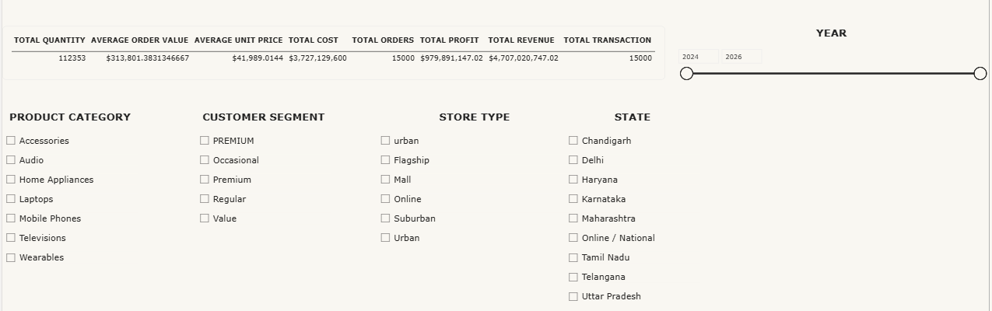
Figure: DAX Validation page with eight measures and five slicers

7. Dashboard Design
The report contains three pages:
Page | Type | Purpose
DAX Validation | Standard (1920 × 1080) | Table of eight measures with five slicers, used to test the model.
Retail Sales Dashboard | Standard (1920 × 1080) | Main dashboard: KPI cards, six charts, a store performance table and five slicers.
Store Type Tooltip | Tooltip (400 × 300) | Custom tooltip with four KPI cards, shown when hovering over the doughnut chart.

Page 2: Retail Sales Dashboard
The main page places four KPI cards across the top, with the category column chart and doughnut chart beneath them and the monthly trend line chart at the top right. The treemap, city bar chart and store bar chart form the lower band, and the slicers and the store performance table sit on the right. Cards and chart text use the Times New Roman font for a consistent look.
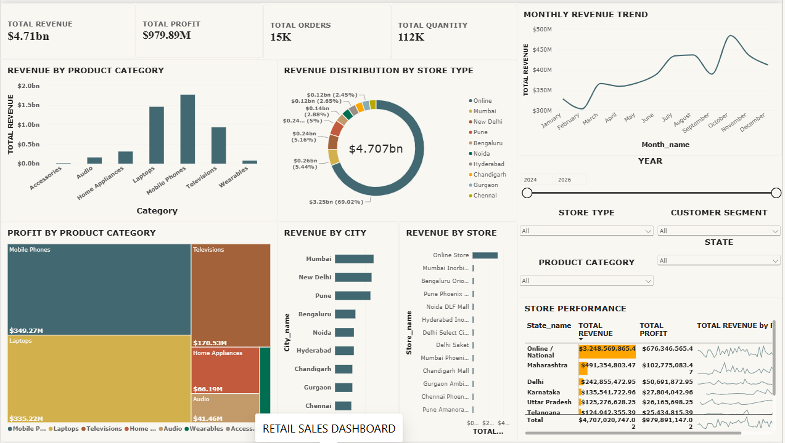
Figure: Retail Sales Dashboard (complete page)

KPI Cards
Four cards summarise the business at a glance. Total Revenue and Total Profit are shown with two decimal places. Overall, the business earned about $4.71bn in revenue and $979.89M in profit from 15,000 orders and 112,353 units sold. Profit is therefore roughly 20.8% of revenue.
Card | Value | Meaning
Total Revenue | $4.71bn | Total sales value across all transactions.
Total Profit | $979.89M | Revenue less cost across all transactions.
Total Orders | 15K (15,000) | Number of distinct orders placed.
Total Quantity | 112K (112,353) | Units sold across all sales records.

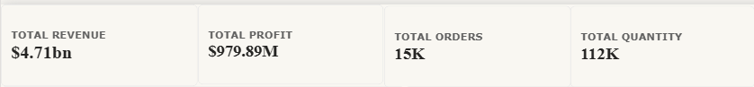

8. Visualizations Used

→ Revenue by Product Category
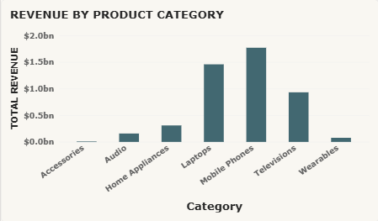

A Clustered Column Chart is used to compare total revenue across product categories. Axis titles and data labels are switched on, and the axis titles are bold. Subcategory is added below category in the X-axis to allow drill-down, so a user can move from category to subcategory. Mobile Phones is the top category at roughly $1.75bn, followed by Laptops at about $1.45bn and Televisions at about $0.95bn. Home Appliances is about $0.33bn, while Audio, Wearables and Accessories are far smaller, with Accessories the lowest.
Fields: X-axis: Dim Product[category] → [subcategory]; Y-axis: Total Revenue.
Purpose:
- To identify the highest and lowest revenue categories.
- To explore revenue at the subcategory level through drill-down.

→ Profit by Product Category
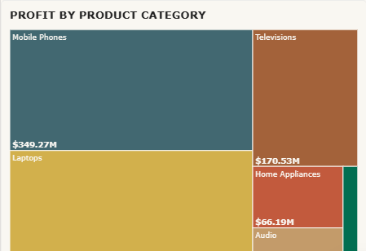

A Treemap is used to show each category’s share of total profit as a block whose size reflects its profit. Bold category labels keep the names readable. Mobile Phones contributes the most profit ($349.27M), closely followed by Laptops ($335.22M), then Televisions ($170.53M), Home Appliances ($66.19M) and Audio ($41.46M). Together, Mobile Phones and Laptops generate about 70% of total profit.
Fields: Group: Dim Product[category]; Values: Total Profit.
Purpose:
- To show how profit is distributed between categories.
- To spot the categories contributing the most profit.

→ Revenue by Store
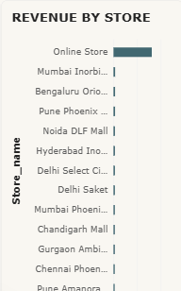
F
A Clustered Bar Chart is used to compare revenue for each store, sorted from highest to lowest, with bold axis titles. The Online Store is far ahead of every physical store, whose bars are very small by comparison.
Fields: Y-axis: Dim Store[store_name]; X-axis: Total Revenue.
Purpose:
- To compare store performance.
- To identify the strongest and weakest stores.

→ Revenue by City
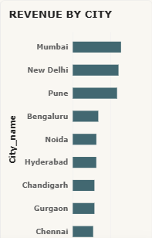

A Clustered Bar Chart is used to compare revenue across cities. A visual-level filter removes the “Online” entry so that only physical city locations are shown. Mumbai, New Delhi and Pune lead, followed by Bengaluru, Noida and Hyderabad, with Chandigarh, Gurgaon and Chennai lower down.
Fields: Y-axis: Dim City[city_name]; X-axis: Total Revenue.
Purpose:
- To compare revenue across physical locations.
- To identify the leading cities.

→ Monthly Revenue Trend
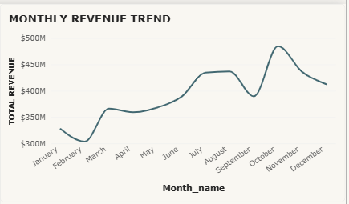

A Line Chart is used to show revenue over time. Year and month name are placed on the X-axis, and month_name is sorted by the month number so that months appear in calendar order. The Y-axis displays values in millions, and year-to-month drill-down is enabled. Revenue is lowest in February (about $305M), rises to roughly $365M in March, climbs to about $435M in July and August, dips in September to about $390M, and peaks in October at about $485M. It then eases to about $412M by December.
Fields: X-axis: Dim Date[year] → [month_name]; Y-axis: Total Revenue.
Purpose:
- To observe seasonality and trends.
- To identify peak and low-revenue periods.
- To drill from year to month.

→ Revenue Distribution by Store Type
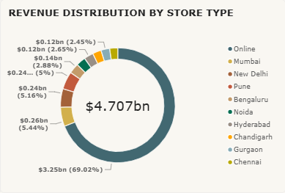

A Doughnut Chart is used to show how revenue is divided into proportions, with data labels turned on. It is linked to the Store Type Tooltip page, so hovering over a segment shows four KPI cards. The “Online” segment dominates with $3.25bn (69.02% of the $4.707bn total). The next largest are Mumbai ($0.26bn, 5.44%), New Delhi ($0.24bn, 5.16%) and Pune ($0.24bn, 5%).
Fields: Legend: Dim City[city_name] (as built in the file); Values: Total Revenue. Note: the assignment specifies Dim Store[store_type] as the legend; this can be switched if required.
Purpose:
- To show each segment’s share of revenue.
- To give extra detail through the custom tooltip.

→ Store Performance Table
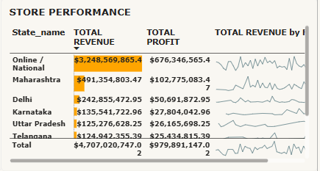

A Table is used to list each row with Total Revenue, Total Profit and a revenue sparkline. Data bars are applied to Total Revenue, and the table is sorted by revenue in descending order so the highest value appears first. The sparkline plots Total Revenue against Dim Date[full_date]. Online / National is the highest row with $3,248,569,865.42 in revenue, followed by Maharashtra ($491,354,803.47), Delhi ($242,855,472.95), Karnataka ($135,541,722.96), Uttar Pradesh ($125,276,628.25) and Telangana ($124,942,355.39). The table total matches the cards: $4,707,020,747.02 revenue and $979,891,147.02 profit.
Fields: Columns: Dim State[state_name] (as built in the file), Total Revenue, Total Profit, Revenue sparkline. Note: the assignment specifies Dim Store[store_name] as the first column.
Purpose:
- To show exact revenue and profit figures.
- To compare values visually with data bars.
- To show the revenue trend for each row through sparklines.

9. Slicers Used
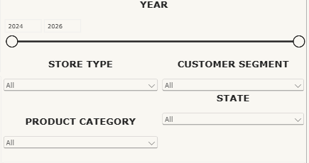
Five slicers were added to the right side of the dashboard. The Year slicer is a range slider covering 2024 to 2026, and the other four are set to Dropdown style to save space. All of them filter the other visuals on the page.
Slicer | Field | Style
Product Category | Dim Product[category] | Dropdown, multi-select
Year | Dim Date[year] | Between (range)
Customer Segment | Dim Customer[customer_segment] | Dropdown, multi-select
Store Type | Dim Store[store_type] | Dropdown, multi-select
State | Dim State[state_name] | Dropdown, multi-select

Because several slicers can be used together, a user can combine filters, for example a particular year with a customer segment and a state, and see every chart and card update at once.

10. Filters at Different Levels
Three levels of filtering were tested on the Retail Sales Dashboard. Each test filter was removed afterwards so the dashboard stayed unchanged.
Level | What it affects | Test performed
Visual-level | Only the selected chart | A single product category was selected on the Revenue by Product Category chart; the other charts were not directly filtered.
Page-level | Every visual on the page | Dim Date[year] was added to Filters on this page and one year was selected; all applicable visuals updated.
Report-level | All pages | Dim Product[category] was added to Filters on all pages; both the dashboard and the DAX Validation page were affected.

11. Drill-Down Features

Category → Subcategory
Dim Product[subcategory] was added below category in the X-axis of the Revenue by Product Category chart. With drill-down mode on, clicking a category column shows the subcategories of that category, and Drill up returns to the category view. In the screenshot the chart is in drilled-down mode and shows revenue for each subcategory. Mid-Range Smartphones has the highest revenue (about $0.6bn), followed by Mid-Range Laptops (about $0.48bn) and Mid-Range TVs (about $0.3bn), while Budget Smartphones, Budget Laptops and Air Conditioners are also visible. Small items such as Cables, Chargers and Adapters earn very little.
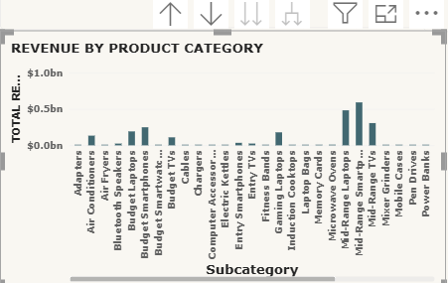
Category drill-down: subcategory

Year → Month
The Monthly Revenue Trend chart holds year followed by month_name. With drill-down on, clicking a year displays monthly revenue for that year; Drill up returns to year level, and Expand all down one level shows months within each year. Month names are sorted by month number so they appear chronologically. The screenshot shows the chart with the drill controls (Drill up, Drill down, Expand all) displayed above it, plotting revenue by month from January to December.
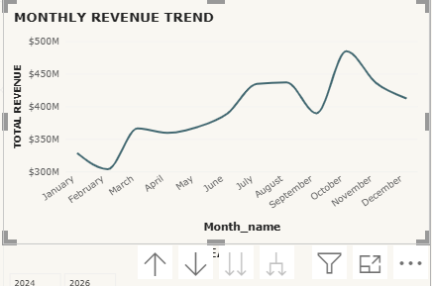
Year-to-month drill-down

12. Store Type Tooltip
A page named Store Type Tooltip was created and set to the Tooltip canvas type (400 × 300). It contains four KPI cards: Total Revenue, Total Profit, Total Orders and Average Order Value. The doughnut chart was configured to use this page as its report-page tooltip, so hovering over a segment displays the four measures for that segment. With no filter applied, the page shows Total Revenue $4.71bn, Total Profit $979.89M, Total Orders 15K and Average Order Value $313.80K.
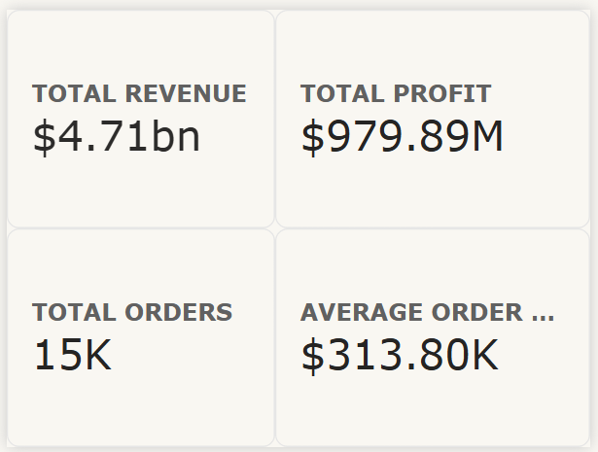

13. Visual Interactions
Edit interactions was used to control how a selection in one visual affects the others. The Revenue by Product Category chart was set to Filter the Store Performance table and to Highlight (or Filter, where Highlight is unavailable) the Revenue by Store chart. These settings change only how visuals respond to selections; they do not change the data model, measures or relationships.
Option | Behaviour
Filter | Shows only the data that matches the selection.
Highlight | Highlights matching data while keeping the rest visible for comparison.
None | Stops the selected visual from affecting another visual.

14. Final Checklist
Feature | Expected behaviour | Status
Five slicers | Filter relevant dashboard visuals | Working
Category drill-down | Category → Subcategory | Working
Monthly trend drill-down | Year → Month | Working
Store Performance table | Revenue data bars and sparklines visible | Working
Doughnut chart tooltip | Displays four KPI measures | Working
Visual interactions | Follow the configured settings | Working

15. Key Findings
- The business generated $4.71bn in revenue and $979.89M in profit from 15,000 orders and 112,353 units, with an average order value of about $313.8K and an average unit price of about $41,989. Profit margin is roughly 20.8%.
- Mobile Phones and Laptops are the two strongest categories, bringing in about $1.75bn and $1.45bn in revenue and $349.27M and $335.22M in profit. Accessories and Wearables contribute very little.
- Mid-Range Smartphones and Mid-Range Laptops are the leading subcategories, so the mid-range price band drives much of the revenue.
- The Online store accounts for $3.25bn, or 69.02% of revenue, far more than any physical store. Among physical locations, Mumbai, New Delhi and Pune are the top cities, and Maharashtra is the leading state after Online / National.
- Monthly revenue is weakest in February, rises through the first half of the year, dips in September and peaks in October at about $485M.
- The slicer lists show inconsistent capitalisation in Customer Segment (PREMIUM / Premium) and Store Type (urban / Urban), which should be standardised in Power Query.
- The currency symbol shown on the visuals is $, whereas the assignment asks for rupees (₹). The format can be changed under Measure tools if rupees are required.

16. Conclusion
The Electronics Retail Sales dashboard brings revenue, profit, orders and quantity sold into one interactive view. Clean data types, a properly related star schema and validated DAX measures give reliable numbers, and the charts, slicers, drill-downs, tooltip and conditional formatting make it easy to compare categories, stores, cities and time periods. The dashboard can support decisions on product mix, store performance and sales planning.

